**Technological Infrastructures and GIS: Webmapping Decisions document**

1. *The Website*

**Web link:** <https://www.geos.ed.ac.uk/~s1997205/web-map/home.html>

**Our questionnaire link:** <https://freeonlinesurveys.com/s/4UQPXx6j>

**Our GitHub link:** https://github.com/hmd84/CGS_webmap/tree/main

The site was created using the following technologies or platform:

* HTML
* CSS
* W3school
* Kwiksurveys

The front-end development part of the web page uses w3school template; the design of the questionnaire part is done using Kwiksurveys web platform.

**Website part:** home, work, map, questionnaire, about, more information

**Website design and function:**

HOME page: This section is a brief description of all the content contained in our group's web page. It is divided into 3 sections, including title, our work, our team.

* The part of the title and our team is only for display.
* The part of our work shows a brief introduction of the work which we want to show on the website. This part is divided into 5 sections (cultural heritage assessment, greenspace quality assessment, map, questionnaire, about)
* Click on the title to jump to the details of the WORK/ MAP/ QUESTIONAIRE/ ABOUT page
* References and the ‘go to top’ button at the bottom of the page

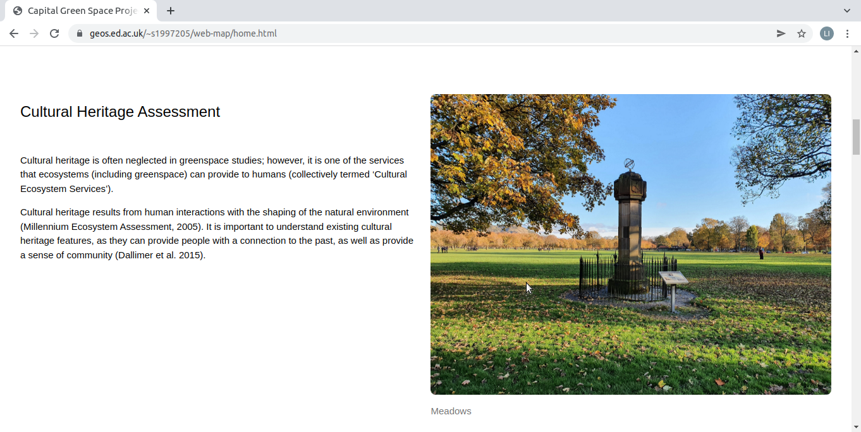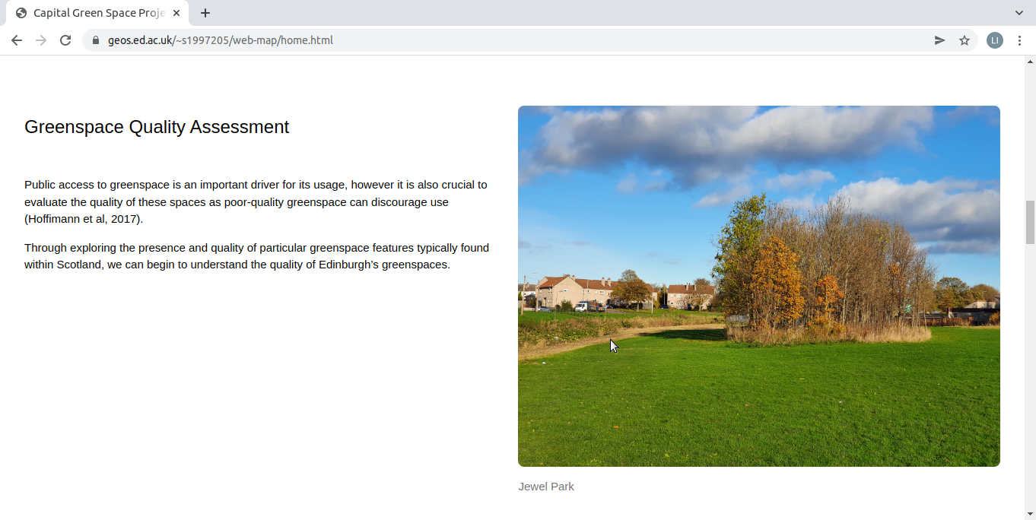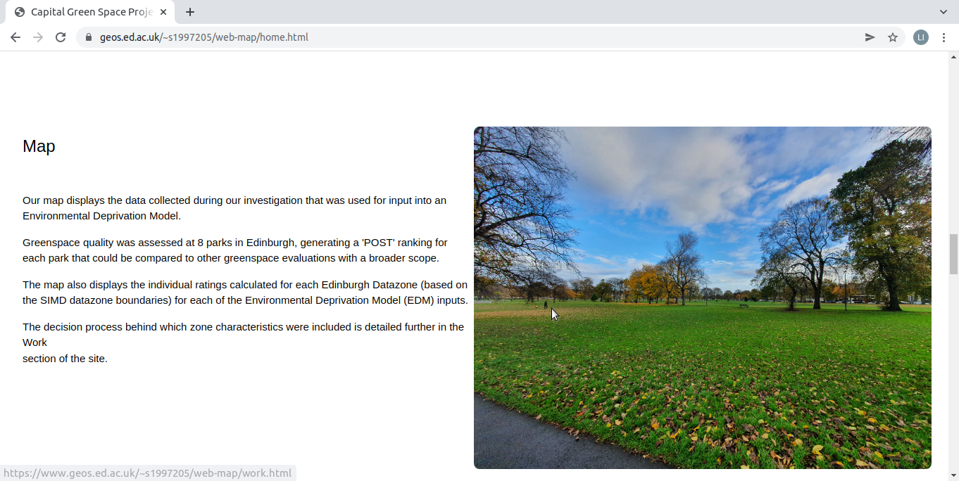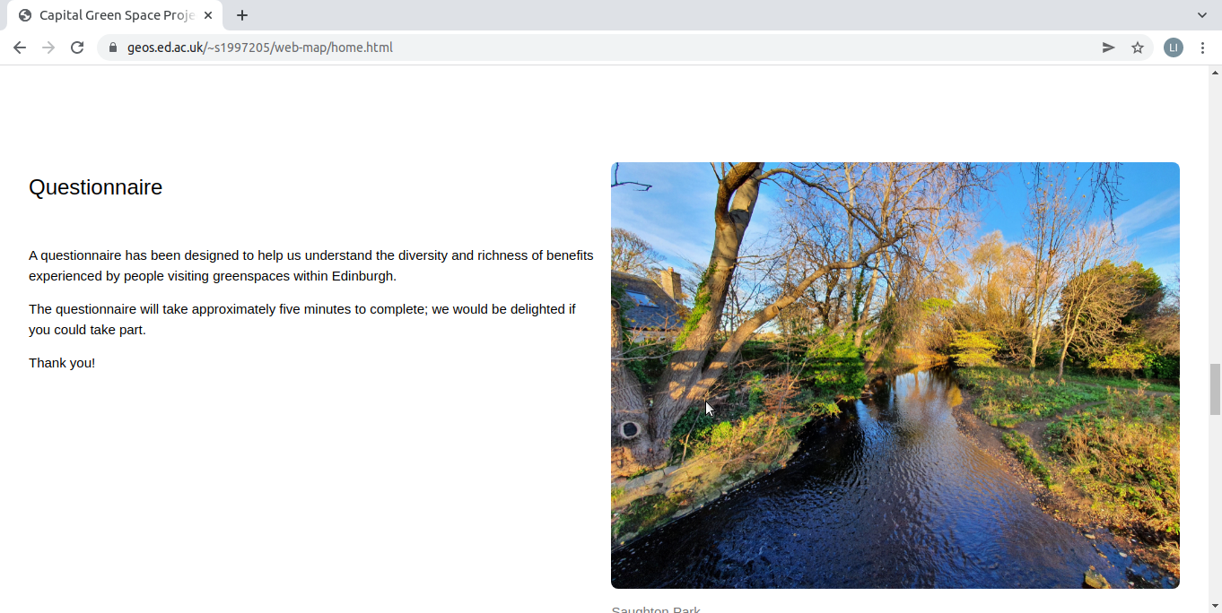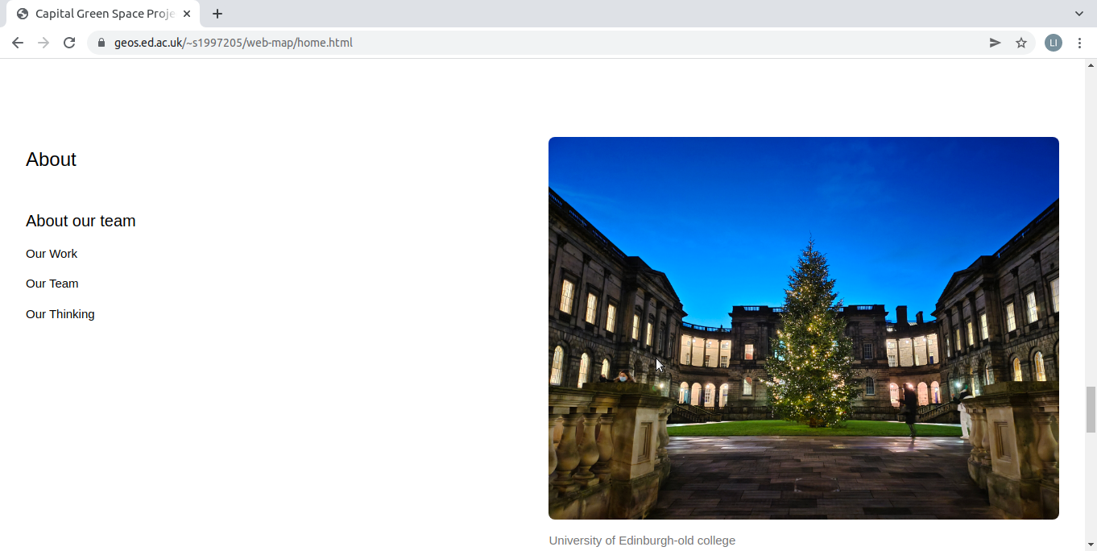

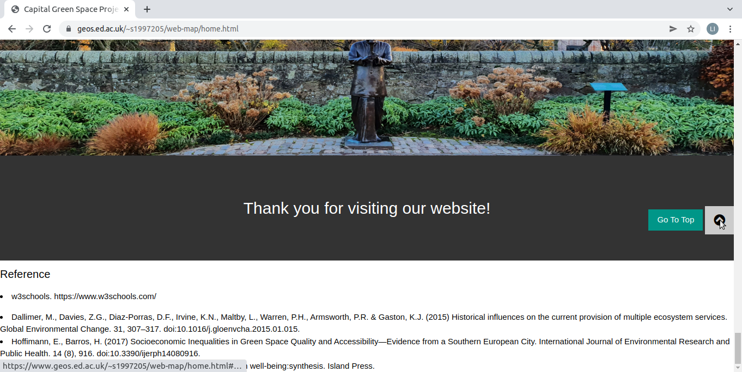

WORK page: The main content is the cultural heritage assessment part and the green space quality assessment part.

* The main content is the cultural heritage assessment part and the green space quality assessment part. Show the methods, databases, and results used by our group.
* The conclusion and discussion section shows the results of our group.
* Click the 'explore our map' button to jump to the MAP page.

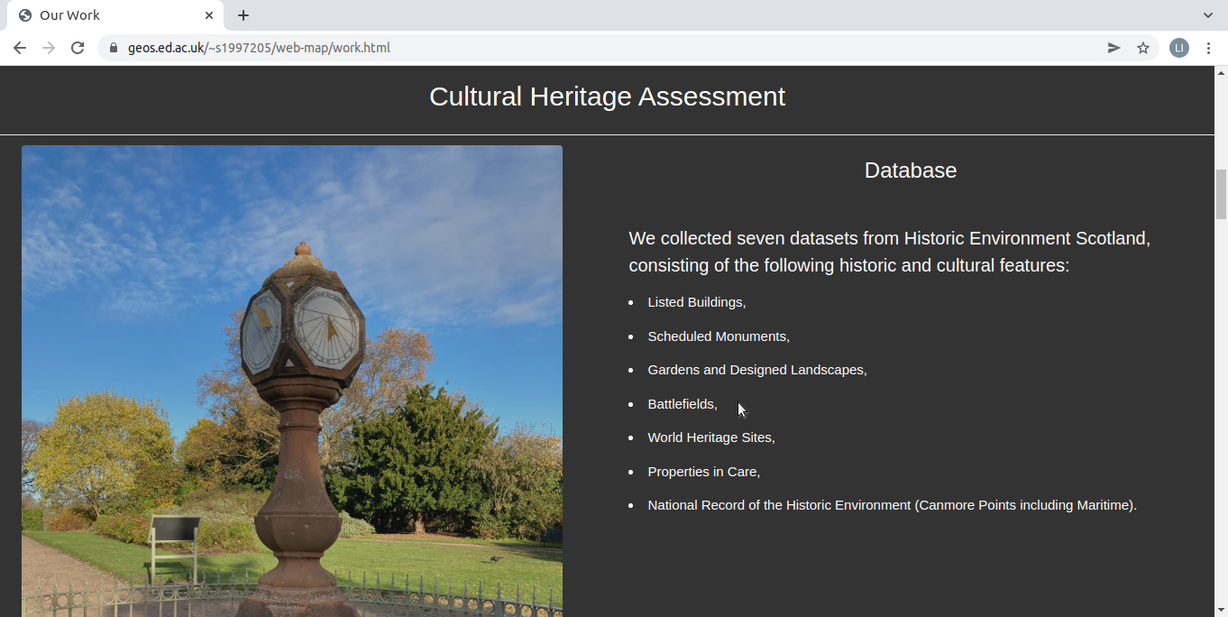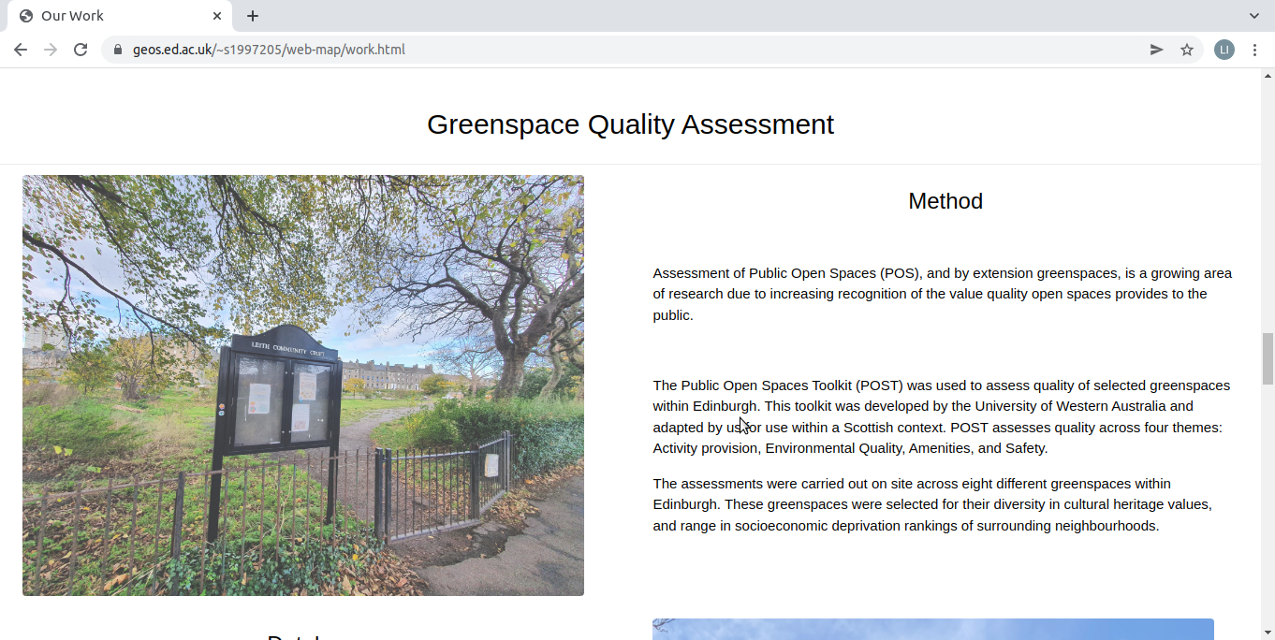

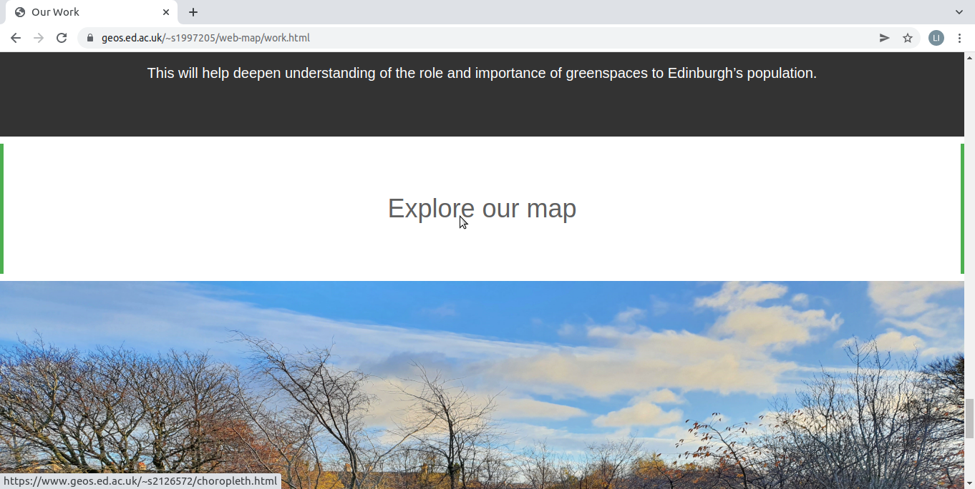

MAP page: Showcases our interactive maps. Includes introduction (introduction contains data and legend) and map.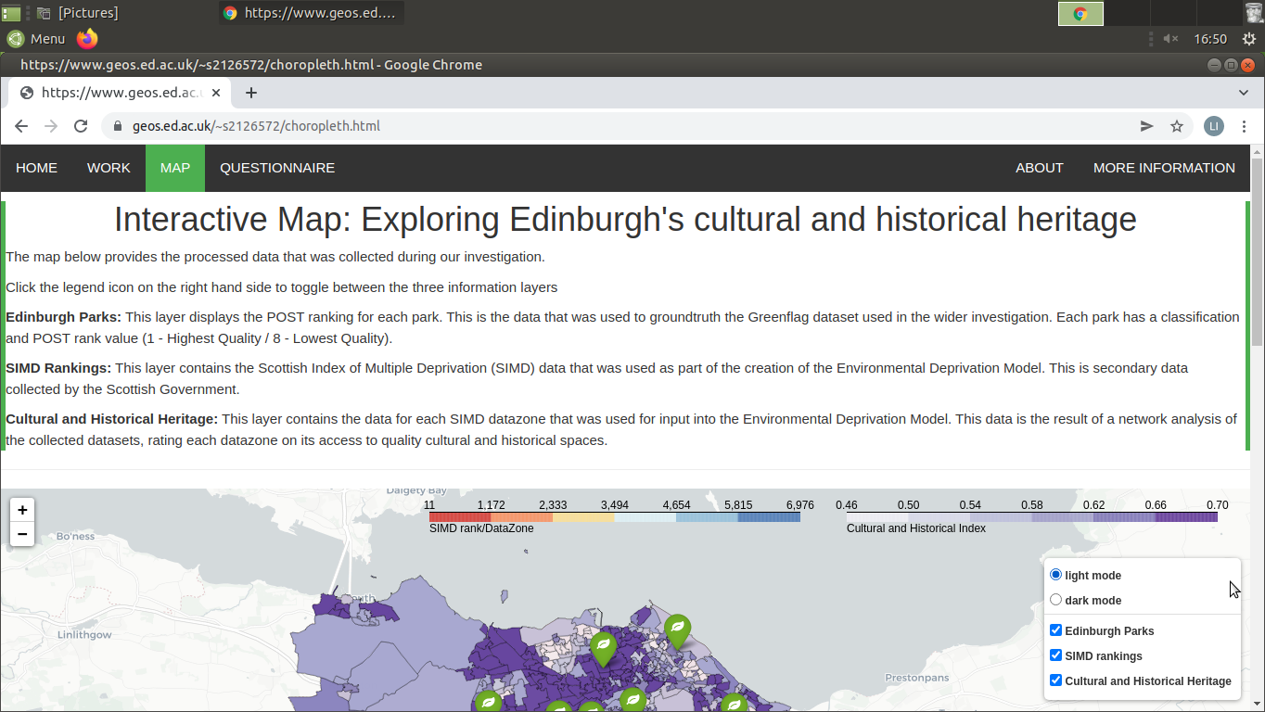

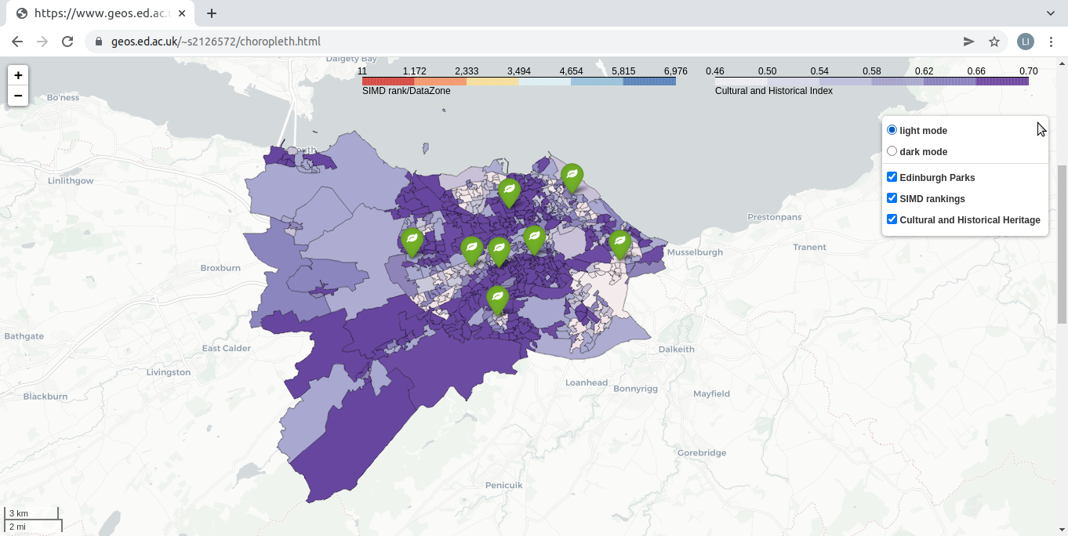

QUESTIONAIRE page: We did not design the EMD-related content in the web page because its data has many limitations, but we designed a questionnaire that evolved based on our conclusion that more information is needed to generate accurate EDM.

* Click on the button to jump to the questionnaire, and you can also explore more of our work by 'show you our work' below.

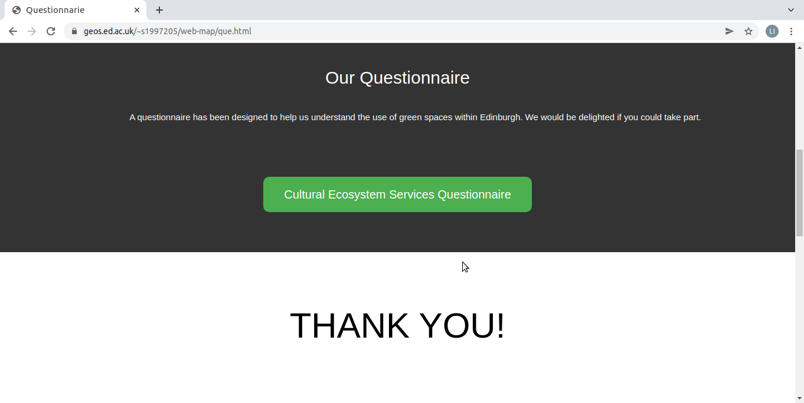

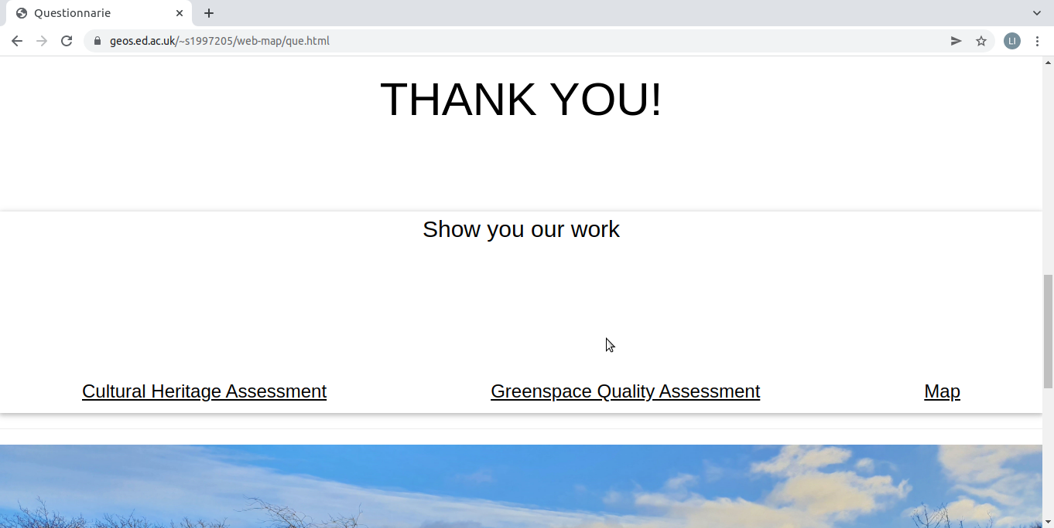

ABOUT page: Briefly describe what we did in the project, show the team members' responsibilities and tasks, and finally show our experience gained.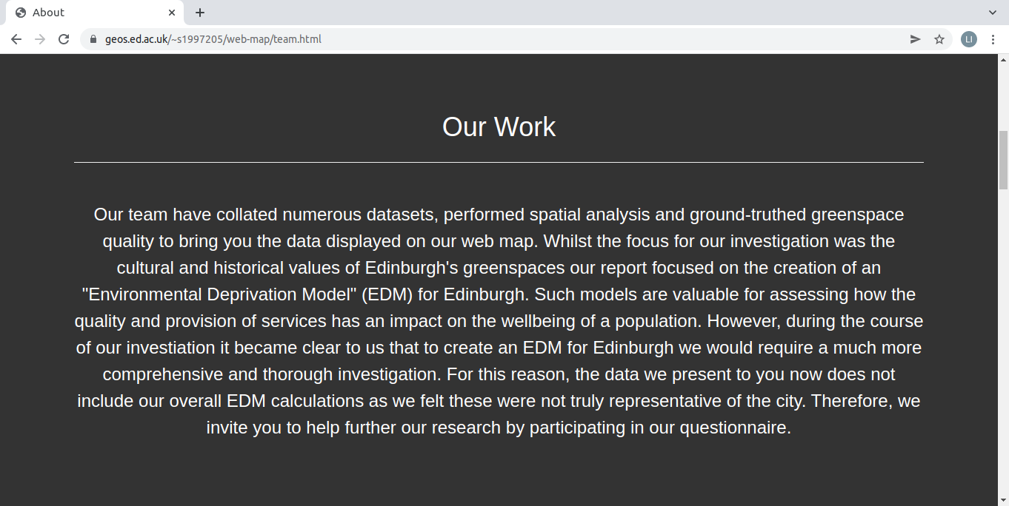

MORE INFORMATION page: We designed this page so that if users want to see what other groups in the greenspace project are doing, they can click on 'Groups' to jump to the home pages of other groups.

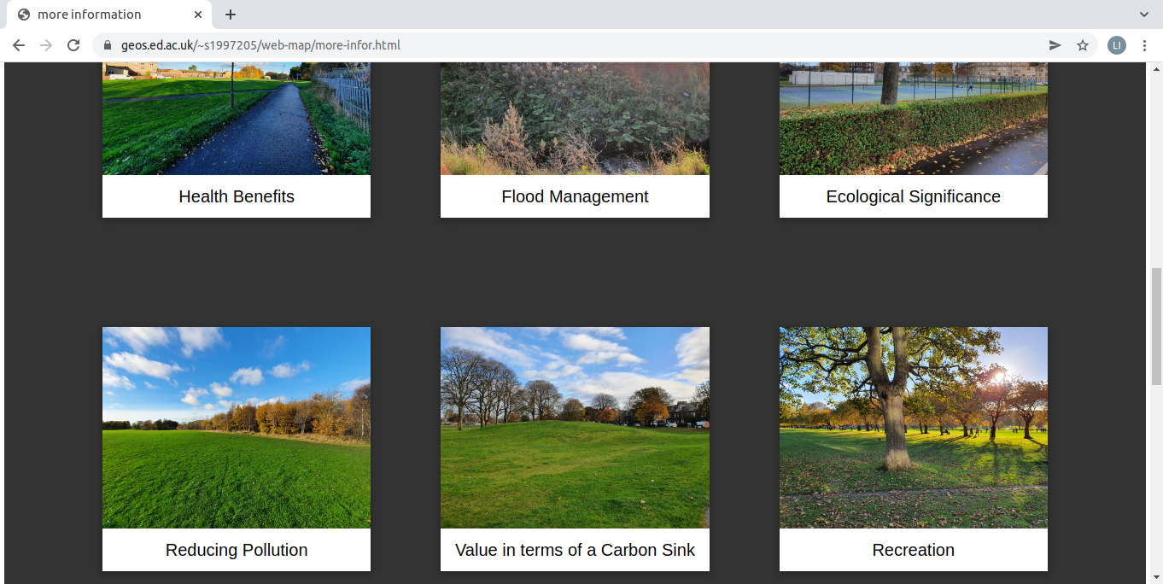

Note:

* All pictures appearing on the web page were taken by the team members
* Considering personal privacy issues, we do not insert photos of our team members or expose other personal information on our web pages.

1. *The Map Component*

Creation of the interactive map was achieved using the following applications:

* Python3
* Folium
* Leaflet
* Geopandas
* cx_Oracle
* Oracle – Database management

Back-End development of the map component for the website was done using the Python package Folium. Folium was chosen as it allowed the combination of the Leaflet mapping service with Python data management to create an interactive map for this task.

**Map Data:**

Across the course of the Capital Greenspace Project investigation, collected datasets were stored in a database management system using Oracle and SQL. ArcMap was also used for the manipulation of shapefiles containing attribute and location data used in our own webmap application.

The first stage of creating the map was the transformation of data to formats compatible for use with python and Folium.

The Geopandas python application was installed and used to convert two shapefiles. The Edinburgh City dataset was converted to a GeoDataFrame containing attribute and geometry data. The Greenspace shapefile was converted to a GeoJSON file as the park attribute data is extracted from Oracle, and so a GeoDataFrame was not necessary.

Both GeoDataFrames and GeoJSON files are easily integrated and manipulated with Folium.

A connection to the Oracle database was established using cx_Oracle. Sensitive information required for the connection was stored in a separate file area away from public_html. This was then read into the Python file to keep this information hidden from the public. The Oracle database was then used to provide attribute data for the 8 greenspaces – their classification title and quality rank.

**Map Design:**

The key focus for our map was to present relevant data to the user in a clear and concise manner. The nature of our investigation led to the collection of several large datasets that went through multiple stages of analysis before reaching the final data outputs.

The decision was made to present the zonal statistics that were calculated from the originally collected datasets. The final data output from the report was also excluded on the basis that we felt it would be inappropriate to present an ‘Environmental Deprivation Model’ to the public having concluded the during the report that extra information and work was required to produce an accurate model.

Choropleth maps were chosen to present the zonal statistic data of the Edinburgh wide dataset. Two maps were generated to reflect the separation of the SIMD data input and Cultural and Historical data inputs. Colour Brewer was used to select appropriate colour schemes for the Choropleth maps and the ability to toggle between dark and light basemap layers was added using Folium Tilelayers to account for user visual preferences when exploring the map.

Greenspaces were loaded onto the map as a GeoJSON file, with associated markers to highlight their location if loaded on the map alongside a choropleth map.

Tooltips with hover functions were chosen for the presentation of the data on the map to reduce screen cluttering and to provide an interactive experience for the user.

One aspect of the map that could be improved upon would be expansion of the Oracle database connection. Current map functionality does not provide a search function for the user to explore the dataset for their own purposes. This function would have elevated the user experience by providing contextual data for the statistics presented on the map.

*Documentation Links:*

|  |  |
| --- | --- |
| **Application:** | **Link:** |
| Folium | <https://python-visualization.github.io/folium/> |
| Leaflet | https://leafletjs.com/examples.html |
| Cx_Oracle | https://oracle.github.io/python-cx_Oracle/ |
| Geopandas | <https://geopandas.org/en/stable/docs.html> |